River Street Tree Program

V5: Draft Proposal- With Amendments

Revision Timeline
- Version 1: Original Draft
  - Jim Talt, June 25, 2026
- Version 2: Formatting for Group Review
  - Jeri Turgesen, June 30, 2026
- Version 3: Integrated Feedback
  - Track changes to include feedback provided to JT by Ad Hoc Committee Members as of July 9, 2026 @ 5:00pm.
- Version 4: Plan Revision based on ODF report and feedback
  - Jeri Turgesen, August 12, 2026
  - Leanne Wagener, September 4, 2026
- Version 5: Edits based upon Scope of work analysis for City Council & adding Silva Cells® graphic
  - Jeri Turgesen & Will Worthey, September 25, 2026
Revision Considerations
- Paragraph numbers [brackets] and line numbers have been added to support group discussion, shared comments, and group editing.
- Please use track changes and/or highlight specific paragraph numbers and line numbers where recommendations for consideration are being made.

[¶1] The River Street Ad Hoc Committee recommends that the City of Newberg adopt the following policies for a River Street Tree Program to support effective replanting of trees optimized for our specific community and environment, supporting long-term cultivation of a healthy tree canopy that provides shade, improves air quality, supports wildlife, and contributes to the aesthetic and economic value of the River Street corridor for generations to come.

Tree Removal and Tree Preservation Guidelines
Relevant Terms:
- River Street Tree Impact Zone: Includes the area of impact to trees as determined in the final design for River Street.
[¶2] The City of Newberg and its contractors will follow recommendations and best practices related to tree removal and preservation, wherever possible. Aspects of tree preservation and replanting for the River Street project will be overseen and supported by the City of Newberg’s Planning Department and the landscape architect of record for the project.
[¶3] The City of Newberg will maintain its current collaborative relationship with the Oregon Department of Forestry Urban Forest Division, taking advantage of their programs and expertise in support of the River Street project.
[¶4] As part of the construction and tree removal process, the City of Newberg, its contractors, and subcontractors will complete the following as part of the pre- and post-construction phases:
- Contract with a certified consulting arborist with appropriate business licenses and credentials to assess and evaluate all trees within the River Street Tree Impact Zone.
- Any tree located inside of the Tree Impact Zone that is determined to be negatively impacted and ineligible for preservation due to substantial construction impacts will be professionally removed at the City of Newberg’s expense. This determination will be made based on the recommendation of the contracted consulting arborist, in coordination with the City’s Planning Department staff.
- Any tree removed, either within the identified 58’ construction zone or the River Street Tree Impact Zone, will be professionally replaced per the tree-replacement program noted below.
[¶5] Any tree within the River Street Tree Impact Zone that is identified as eligible for preservation will receive the following protections:
- Every tree within the River Street Tree Impact Zone identified for preservation will have a tree-specific identified ‘Tree Protection Zone’ established by the consulting arborist in collaboration with the City of Newberg Planning staff. The Tree Protection Zone will be formally delineated by a chain link fence (plastic barrier construction mesh will not be accepted) to ensure every tree eligible for preservation has an appropriate and undisturbed protection zone for the entirety of the construction project.
- The Engineering team, contractor, and any subcontractors identified through the RFP process will coordinate with the certified consulting arborist and/or the City of Newberg Planning staff before conducting any excavation, grading, paving removal, utility installation, or construction activity within designated Tree Protection Zones.

Tree Replacement & “Trees For Everyone” Program
Relevant Consideration: All tree selection will be guided by the finalized River Street Tree Pick List currently in development.
[¶6] To ensure a healthy and inviting tree canopy for future generations of residents and wildlife, the City of Newberg will replace any tree removed due to the River Street project, including those within the Planter Strip or the assessed Tree Impact Zone.
[¶7] The City of Newberg will offer up to two free planter-strip trees and professional installation to any River Street homeowner who requests one, provided the location is practical and there is sufficient spacing available for two trees (e.g. considering appropriate long-term growth and spacing, infrastructure constraints, etc.), ensuring long-term tree health and survival.
- Replacement planter-strip trees and/or replacement trees within the Tree Impact Zone may need to be planted in a slightly different location than the original tree due to street design, infrastructure constraints, professional/arborist opinion, long-term tree health and survival, etc.
- The total number of trees and species planted will ultimately be determined in collaboration with the homeowner and with expert input from the consulting arborist and City of Newberg Planning staff.
[¶8] Those properties with no trees located within the planter strip at the time of River Street construction initiation will similarly have the choice to select two newly installed trees as part of the ‘Trees for Everyone’ Program.
[¶9] Tree replacement caliper range will be consistent with recommendations from both consulting experts and the City of Newberg Planning staff.
[¶10] If a tree from the approved River Street tree picklist is not available at the time of replanting, availability constraints and tree preferences will be discussed with the homeowner. Additionally, the River Street Ad Hoc Committee will be convened to review any identified limitations for the tree list, including caliper limitations in tree availability, and may make updates to the River Street Tree Recommendation List as needed.

Tree Location and Planting Requirements
[¶11] To promote healthy tree development and protect street infrastructure from future root-related damage, all new trees within the planter strip will be planted with rigid, root-guiding matrix modules that include integrated vertical ribs that are designed to direct roots downward, while allowing lateral root development below pavement depth. Modules utilized will specifically be the DeepRoot Silva Cells® or an approved equal.
- Any consideration for an approved ‘equal’ to the DeepRoot Silva Cells® must be formally evaluated and approved by the City Tree Expert as a sufficient and equal alternative prior to any installation and use.
Figure 1: Silva Cells® below grade structure
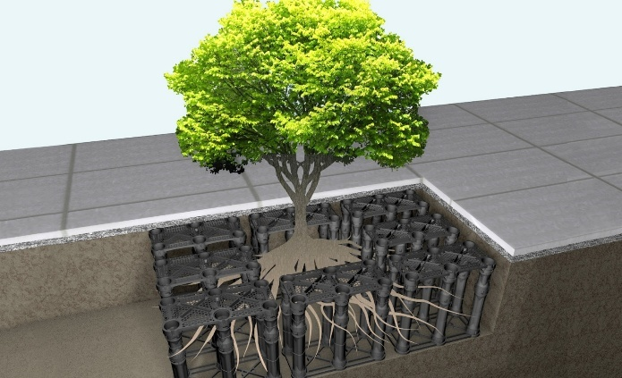

[¶12] New tree planting locations (not individual tree selections) should be identified and approved prior to the start of construction, once the full survey is completed and specific impacts to the Tree-Impact Zone are known. Planting areas should avoid unnecessary soil compaction to encourage desirable downward root growth.

Care and Maintenance
[¶13] For trees planted in the River Street planter strips, the City of Newberg and/or its landscape maintenance contractors will provide growth pattern maintenance and regular deep-root watering, using Treegator watering bags (or an equivalent watering system). This care will continue for four years after planting to support successful establishment and ensure proper, healthy, early growth patterns.
[¶14] If a tree planted as part of the River Street Project dies of natural causes prior to the four years, the City of Newberg will replace and professionally install a replacement tree as quickly as possible for the homeowner and will continue the maintenance and watering of that tree for the identified four-year period.

Tree Type / Species Selection
[¶15] A River Street Tree Pick List will be developed consisting of species specifically approved for River Street conditions. The list should include:
- Ample “power line friendly” (smaller stature) trees suitable for the east side.
- A good selection of medium-to-tall trees suitable for the west side.
- Several attractive flowering/ornamental trees.
[¶16] The Pick List should be created by the River Street Ad Hoc Committee, with guidance from certified experts familiar with Newberg’s climate, soils, and urban conditions. Tree selection should take into consideration River Street Design information to ensure that identified trees are appropriate to the location, planter strip width, etc.
[¶17] Diversity notes: River Street will have tree diversity. The City of Newberg and/or its Contractors will not plant a single species along the entire corridor. This approach to tree selection and planting is required due to disease and pest vulnerability. The final list should aim for an attractive, cohesive overall aesthetic, as determined by the River Street Ad Hoc Committee and established in the River Street Tree Pick List.

